

HORTICULTURE

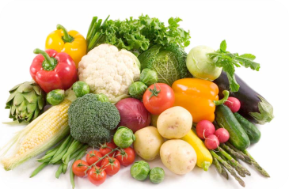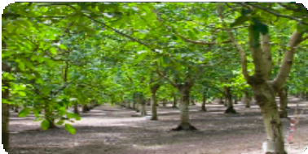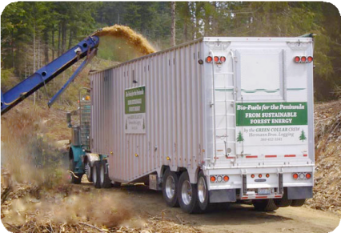

ORGANIC FARMERS

**CAL BIOMASS ATLAS**

***Converting Residue into Biochar & Energy Through Carbon Negative Processes***

**AG RESIDUE FEEDSTOCK**

*Example Closed Loop Processing Scenario*

Transportable Refrigeration 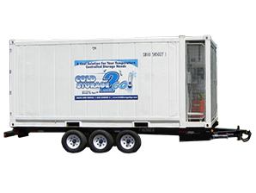

Qualterra Pyrolysis Unit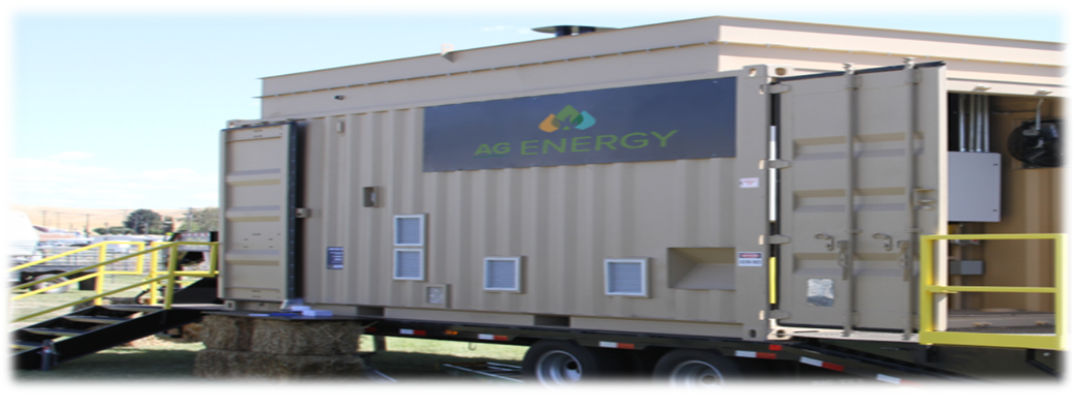

**Absorption Chilling**

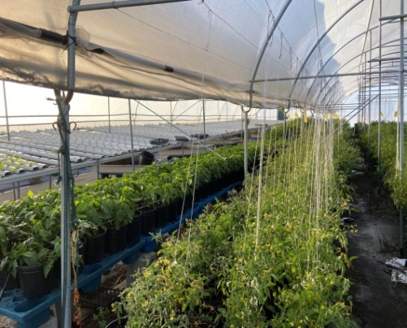

**BIOCHAR**

*Carbon*

*Storage*

**BIOMASS RESOURCE CONSERVATION**

**Developing CAL BIOMASS ATLAS (CBA) Outline Draft**

* **Purpose** will be a condensed view of what the past, present and anticipated vision related to California Agriculture’s biomass conversion technologies and infrastructure. The Atlas will include public interest facts related to the planets carbon cycle process.
* **Non-profit Marketing**, the Atlas will be available through several non-profit organizations and Academic sources. An example is UC ANR Master Gardener program is each county: <https://mg.ucanr.edu/>
* **Diversity,** considering the complexity of the issues and AB 32 regulations the Atlas will cover projects, statistics and logistics focused on individual counties. Projects in progress in Butte, Colusa, Merced, and Madera Counties will be the flagship examples and organizational model.
* **Advisors**, each county has UC ANR Ag Extension farm advisors, they will have opportunity for peer review for content accuracy and demonstrations validation. CDFA and County Farm Bureau staff will also be invited for peer review. All the information will be empirical based with validated documentation.
* **Curriculum,** there may be collaboration between California Farm Bureau, Ag In The Classroom (AITC) program Learning About Ag; <https://learnaboutag.org/>
* **Content,** separate sections and subcategories covering, increased food production through improved soil health with biochar blended with organic products, feedstocks management, mobile field systems, stationary onsite systems, and other biomass mitigation related components.
* **Funding,** the incubation and seed funding will be a combination of sponsors and advance purchase orders. The early sponsors will have a full-page outreach write up about their company and services.
* **Purchase,** the price for the first edition Cal Biomass Atlas is estimated to be about __? It may be adjusted lower as volume production is increased.

**Agriculture Biomass is Food, Fiber & Energy**

The **CAL BIOMASS ATLASS (CBA)** primary objective will be a snapshot of empirical documentation related to Ag residue mitigation and soil remediation to secure long term benefits to California's air, water, soils, and food production. It will include technology applications of biomass mitigation and soil health improvement. CBA is now being prepared for digital publication in 2023. Seed funding for the writing and publishing of the first atlas will be provided by advanced purchase.

**Planet Carbon Cycle Chart:**

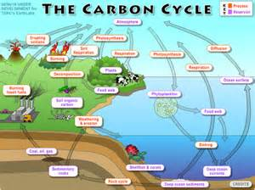

The goal is a validated and pragmatic snapshot showing the importance, yet complexity of the biomass recycling challenges in California’s Agriculture industry, County by County.

**Agriculture Biomass Carbon Cycle Chart:**

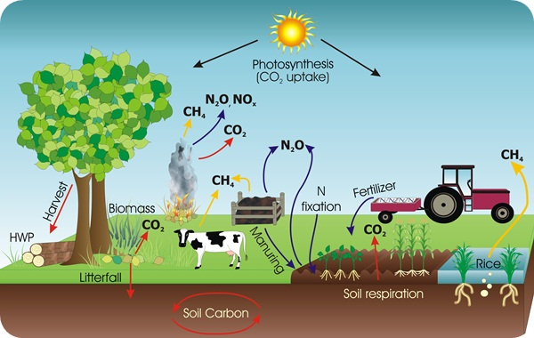

**1. What Is Biomass?**

* + The Process of Converting Biomass into Energy, Biochar and Biofuel
  + The History of Biomass Industry in California
  + The Future of Biomass Industry in California

**2. Uses and Products of Biomass Conversion**

* Improved Soil Health & Erosion Control
* Water Conservation & Filtration Methods
* Biochar, Compost, Pellets, Bio-power, Biodiesel

**3. Benefits of Biomass Remediation Applications**

* California's Three Agricultural Zones
* Carbon Sequestration Water Conservation Soil Amendment
* Water Filtration
* Biochar & soil amendments
* Urban Forestry and Reducing landfill space.
* Renewable Energy

**4. Research and Development**

* Case Studies of Existing and Current Project Development Sites
* Applications for Citizen Gardeners & Organic Farmers
* Job Creation & Opportunities

**5. Glossary of Terms & Technical Conversion Tables**

**6. Table of Production for Various Technology Systems**

**7. Generous Sponsors for Cal Biomass Atlas**

*Technical Knowledge & Empirical Experience Accumulated Over 30 Years!*

[greencarbonnexus.org](http://greencarbonnexus.org/)

GCN Office: 2963 Davison Ct, Colusa CA 95932  *530-966-2882*